**INTERVIEW RELATED CSS QUESTION & TOPICS**

1. Box Model

2. CSS Units

3. Display

4. Display Game

**1. Box Model**

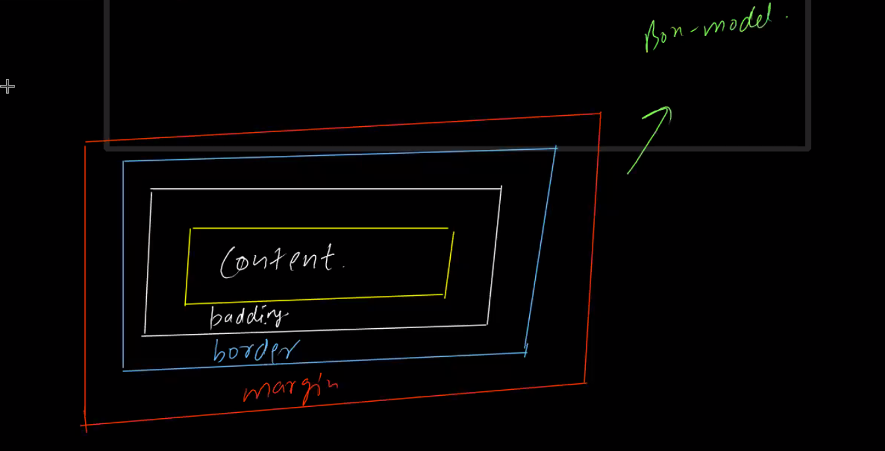

Browser shows all below tag in rectangular form

<div> </div>

<p> </p>

<strong> </strong>

**Padding**

* spacing between content & border
* padding does not increse size of content

**Border**

* increse or decrese border size

**Margin**

* spacing between elements
* spacing between two tabs
* eg : input

button

paragraph

* spacing between input & button or button & para

**2.CSS units**

(1)Absolute

(2)Relative

(1)Absolute

px == fixed value , mostly avoid karna hai ,agar kahi pe fix value chahiye toh hi use karna hai

(2)Relative

**rem :**

=>Multiple of it's root element's font-size

=> 1 rem = 1* 16px(multiple of html tag Font-size value according browser )

=> 2 rem = 2*16px

=> 3 rem = 3*16px

**em :**

=> multiple of it's parent element's font-size

**vh** => viewport ( Height ) give output % of viewport in height

**vw** => viewport (width) give output % of viewport in width

**%** => % of parent element

**3. Disply**

**block** -- fully occupy space according whole block

-- height & width de sakte hai

-- new element comes in next line

**inline** -- occupy space according to content

-- height & width nahi de sakte

-- new element comes in side

**inline-block** -- all property of inline

-- height & width de sakte hai

**flex** --

-- justify-content : for horizontally changes

-- align-items : for vertical changes

For CSS flex property play : FLEXBOX FROGGY game on google